|  |
| --- |
| SVKM’s NMIMS University  Mukesh Patel School of Technology Management & Engineering  **B Tech SEMESTER V**  **SUBJECT: Advanced Web Programming Practical: 10**  **Part A (To be referred by students)**  **Topic: Mongo DB with Node JS** |
| **Aim:** To perform CRUD operation in MongoDB with Node JS or PHP.   1. Installed MangoDB 2. Create MangoDB database master 3. Create collections student in MangoDB 4. Insert records in MangoDB collection student 5. Display data from a collection in MongoDB 6. Deletes record from collection 7. Drop Collection from MangoDB 8. Designed Node JS script to insert and display records from MongoDB. |
| **Prerequisite:** HTML, CSS, Database |
| **Outcome:** To impart knowledge of NOSQL using MongoDB/MYSQL and NodeJS |
| **Theory:**  NOSQL   * When people use the term “NoSQL database”, they typically use it to refer to any non-relational database * Some say the term “NoSQL” stands for “non SQL” while others say it stands for “not only SQL.” * NoSQL data models allow related data to be nested within a single data structure. * As storage costs rapidly decreased, the amount of data applications needed to store and query increased * This data came in all shapes and sizes—structured, semistructured, and polymorphic—and defining the schema in advance became nearly impossible. * NoSQL databases allow developers to store huge amounts of unstructured data, giving them a lot of flexibility. |

|  |
| --- |
| MangoDB   * MongoDB is an Open Source database written in C++. * It can be used to store data for very high-performance applications (for example Foursquare is using it in production). * MongoDB is a document-oriented NoSQL database used for high volume data storage. * Instead of using tables and rows as in the traditional relational databases, MongoDB makes use of collections and documents. * Documents consist of key-value pairs which are the basic unit of data in MongoDB. * Collections contain sets of documents and function which is the equivalent of relational database tables.   **Working With Mongo DB.**  Use the Following URL, if you have not installed MongoDB on your system. |
| <https://mws.mongodb.com/>  **Task 1.1 To be Performed**  1. To Create database in MongoDB use following Command. Use MBA Tech |
| 1. Create Collection Student      1. Insert records in MangoDB collection student      1. Insert Multiple Records |

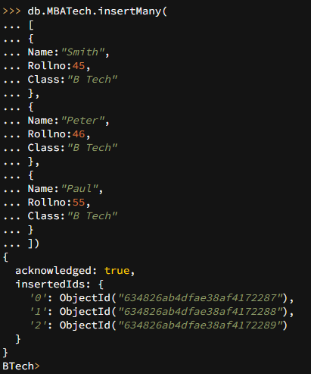

1. Display data from a collection in MongoDB



1. Deletes record from collection



1. Delete Many Records from Collection in Mongo DB
2. Drop Collection from MongoDB

# Task 1.2 to be performed

Create Collection Learning and Insert Details about Books as given below and Performed CRUD Operation.

{

bookid:1, author:"Smith", bookname:"HTML",

Price:450, Status:'A'

}

# Instructions:

1. Write source code of all html tags.
2. Copy code & paste in code section of Part B.

|  |
| --- |
| **Part B** |
| **Code:**  Perform the operation & paste running code here  **Task 1.1:** |

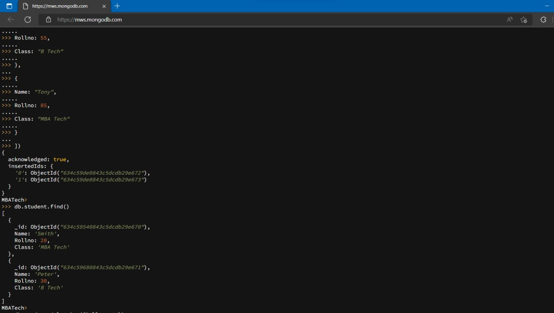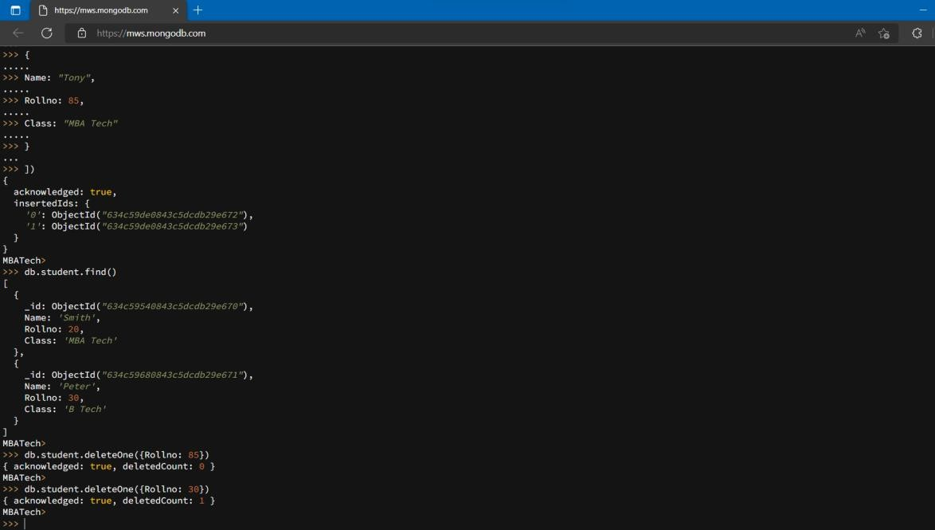

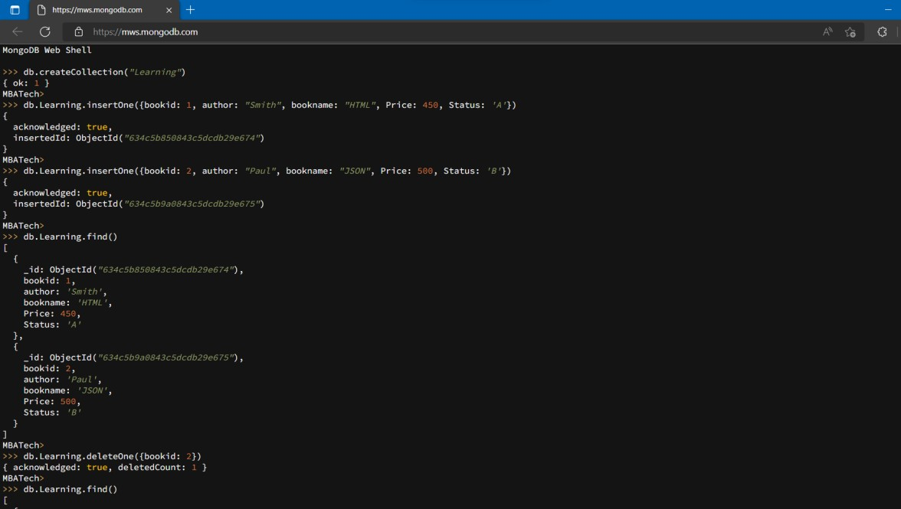

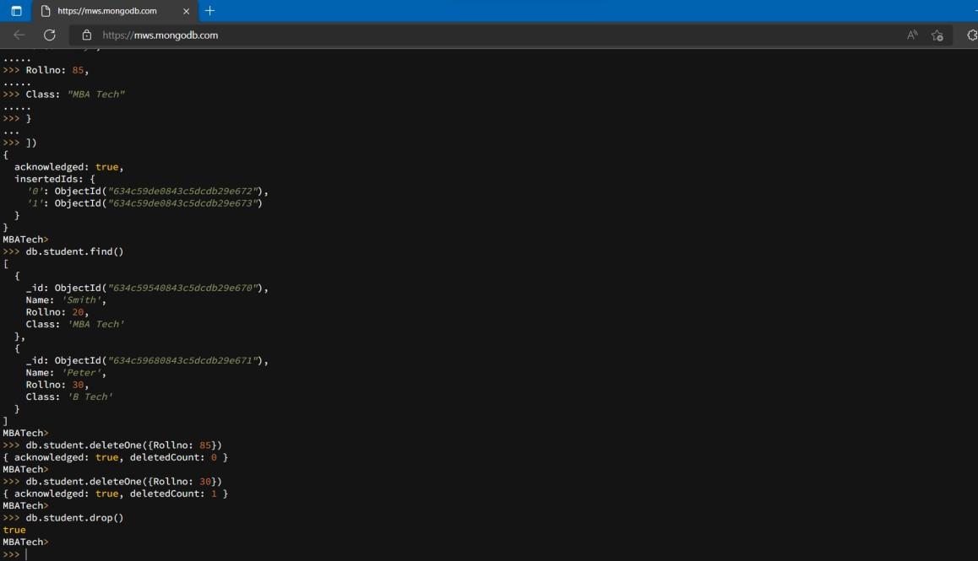

**Task 1.2:**

|  |
| --- |
|  |
|  |
| **Observation & Learning:**  Write your Observations & Learning after performing task   * Learned about MongoDB. * Learned how to write queries in MongoDB. * Learned about different operations and how to perform them in MongoDB. |
|  |
| **Conclusion:**  Write statement of conclusion here   * Successfully understood and implemented different queries in MongoDB. |